|  |  |  |  |  |  |
| --- | --- | --- | --- | --- | --- |
| Date | 30-Nov-22 | | | Tester Name | Shahabuddin Syed |
| Environment | Penfax - Test | | | Login used |  |
| Operating System | Windows | Version: | Update: | | |
| Software Used | Edge | Version: | Update: | | |
| Select Software | Version: | Update: | | |
| Release version | 22.4.1 | | | | |
| Title | M49.08 – Data Posting Batch | | | | |
| Test Type | Regression | | | | |
| Test Scenario | Data Posting Batch Window | | | | |
|  |  | | | | |
| Expected Results |  | | | | |
| Pass/Fail | Pass | | | JIRA# | 6597 |

Describe your steps with screenshots:

Login into Penfax application

Go to Batches

Select Data Posting Batches from the dropdown list

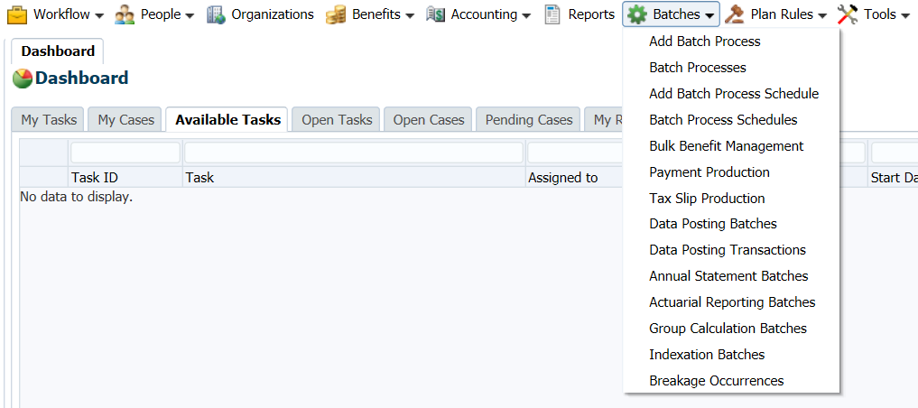

Under Search Parameters

Select Plan as ‘MEPP’

Select Batch Type as Contributions from the dropdown list

It Search for all the Batch Status such as Open, Closed, Cancelled

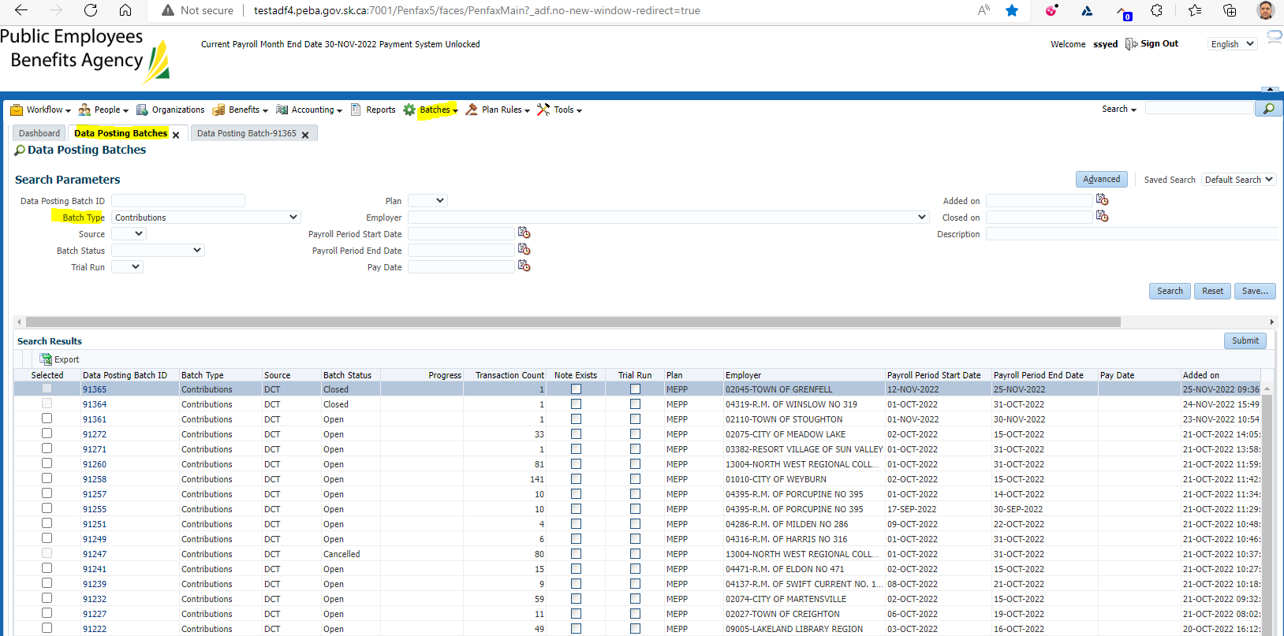

Result: Pass